Team UH

2016 Swarmathon Outreach Report:

*Reaching the next generation!­­­­­*

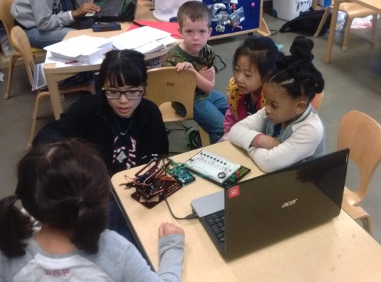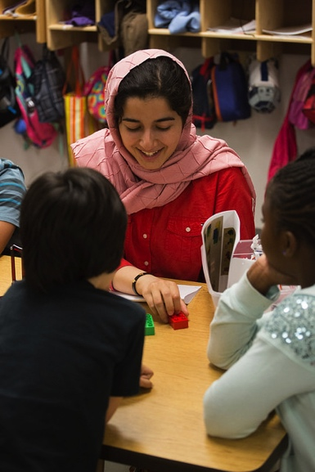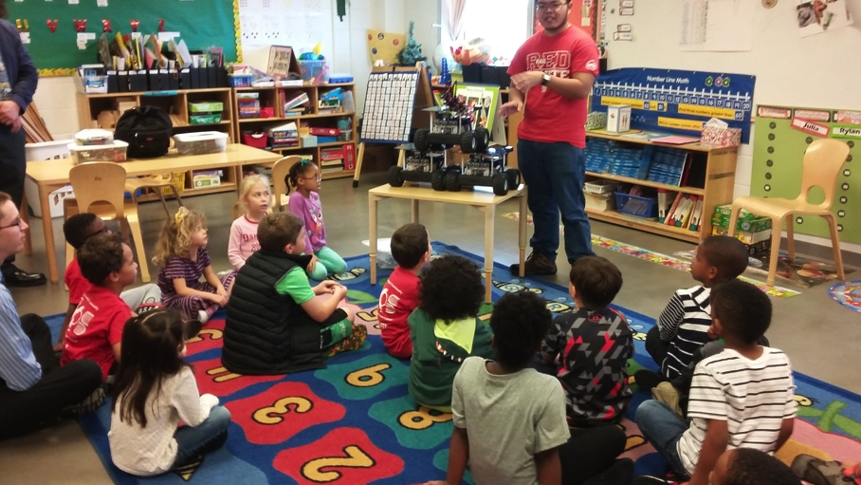

Li Huang, An Nguyen, Mary Burbage, Lillian Lin[1]

University of Houston

Dr. Aaron T. Becker



The US faces a severe shortage of future engineers[2]. In particular, minorities and women are underrepresented in STEM fields[3]. To help change this, the University of Houston’s *swarmathon* outreach activities targeted a young audience, believing that introducing robotics activities to middle school and younger children sparks an early interest in STEM fields. This interest both enables students to picture engineering as a possible field and encourages students to go to college.

In addition to an active facebook[4] and twitter[5] presence, the University of Houston Teamplanned and implemented two key outreaches. The first encompassed multiple visits to the *University of Houston Charter School* to teach primary students the basics of robotic control. Located in the heart of the Third Ward of the Greater Houston Area, the UH Charter School reflects the neighborhood demographics [23% African American, 43% Hispanic, 26% White, 5% Asian, 41% economically disadvantaged[6]]. The second, *Making Jwelery with Robots,* was a hands-on activity as part of *Chevron’s Girls Engineering the Future* designed to encourage females to try out engineering for a day. During this event, we taught girls to use our rapid prototyping machines including our laser cutter, CNC mill, drill-press, 3D-printer, and hand tools to make jewelry.

On February 23rd 2016, the University of Houston Teamvisited University of Houston Charter School to teach 22 enthusiastic kindergarteners the basics of robotics. Each University of Houston Team member is also enrolled in Dr. Becker’s *Intro to Robotics* class. This gave them the confidence to each teach a groups of three to four kindergarten students. Over the next hour they used a series of games to teach the concepts of *workspace*, *degrees of freedom*, and both *forward* and *inverse kinematics* robot control.

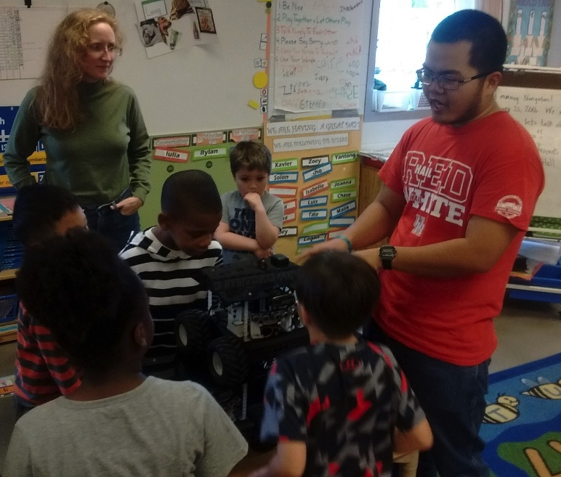

**Figure 1 – Team members An Nguyen (right) and Mary Burbage (left) introducing UH charter school kindergarten students to the NASA Swarmie robots. Every child had an opinion on the best way to use the Swarmies to find treasure.**

After letting each child describe what they know about robotics, the lesson began. Each student brought a laser-cut, four-joint robotic manipulators, and used these to illustrate the concepts of a robot workspace and helped the children count degrees of freedom. To teach forward and inverse kinematics, the university students acted as a blind robot while the kindergarten students shouted out commands to directing the university students to pick up Duplo blocks. For simulate forward kinematics, each part of the body was designated as only going in two directions (rotate waist left/right, rotate shoulder up/down, elbow in/out, hand open/close). In contrast during the second game the children directed their ‘robot’ in directions relative to the robot hand (move hand forward/backward, left/right, up/down, open/closed). These activities illustrated the difference between forward and inverse kinematic control. The third activity simulated programming. One of the kindergarten students was given four Duplo blocks and named the ‘robot’, while the other students rolled a dice to select a block configuration from a list. These students needed to use words to instruct their robot how to correctly construct the block structure. Next, the university students powered on their robot arms—to the general delight of the children. The class ended by calling all the students together and introducing them to the swarmie robots for a brief presentation about NASA swarmathon—and a long time for questions! This allowed the students to see how all this information came together to make a robot.

The outreach was so popular that the Swarmathon Team was invited back to the Charter School to teach robotics to 2nd Graders on March 1st 2016. We used feedback from the previous outreach with the kindergarten, to improve the language and printed material to be more accessible to the children. Copies of the agenda, outreach materials, and evaluations, are at our github repository[7].

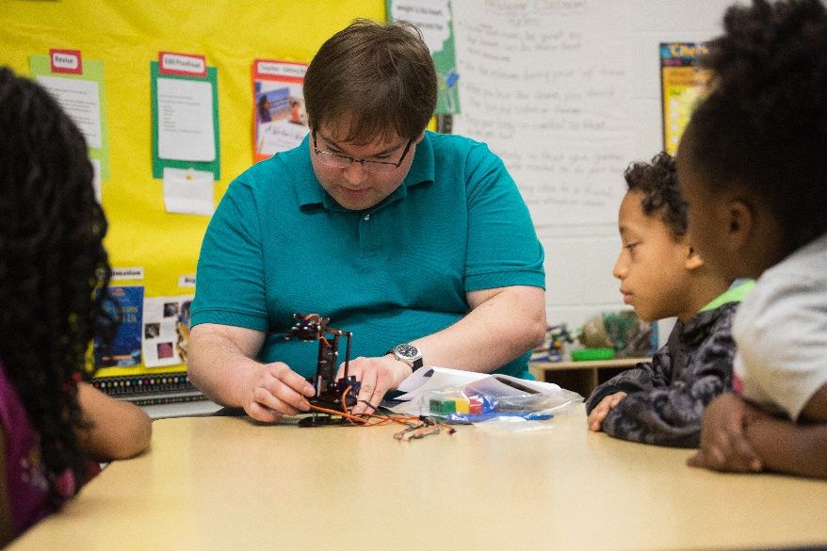

**Figure 2 - Team member Jordan Bowman demonstrating the robotic manipulator to the 2nd grade class**

In both outreach events, the students were verbally asked questions as a pretest to assess their knowledge and awareness of robotics. They were later given posttests to evaluate their knowlege (all results available online[8]). In both cases, students showed an increase in the vocabulary associated with the projects. Over 60% of students correctly understood both the concept of workspace and identified the amount of degrees of freedom on the robot manipulator.

Student impact, measured by posttest scores varied from kindergarten to 2nd grade. The 2nd graders had both a higher literacy for the posttest questionnaire and experienced a refined version of the outreach with practices college student leaders. This biases the results in favor of the older class and is not a perfect representation of the outreach impacts. Regardless, one obvious impact of the outreach was the students asking us back to their school to teach. We are currently brainstorming more activities to continue feeding these students’ interest in engineering.

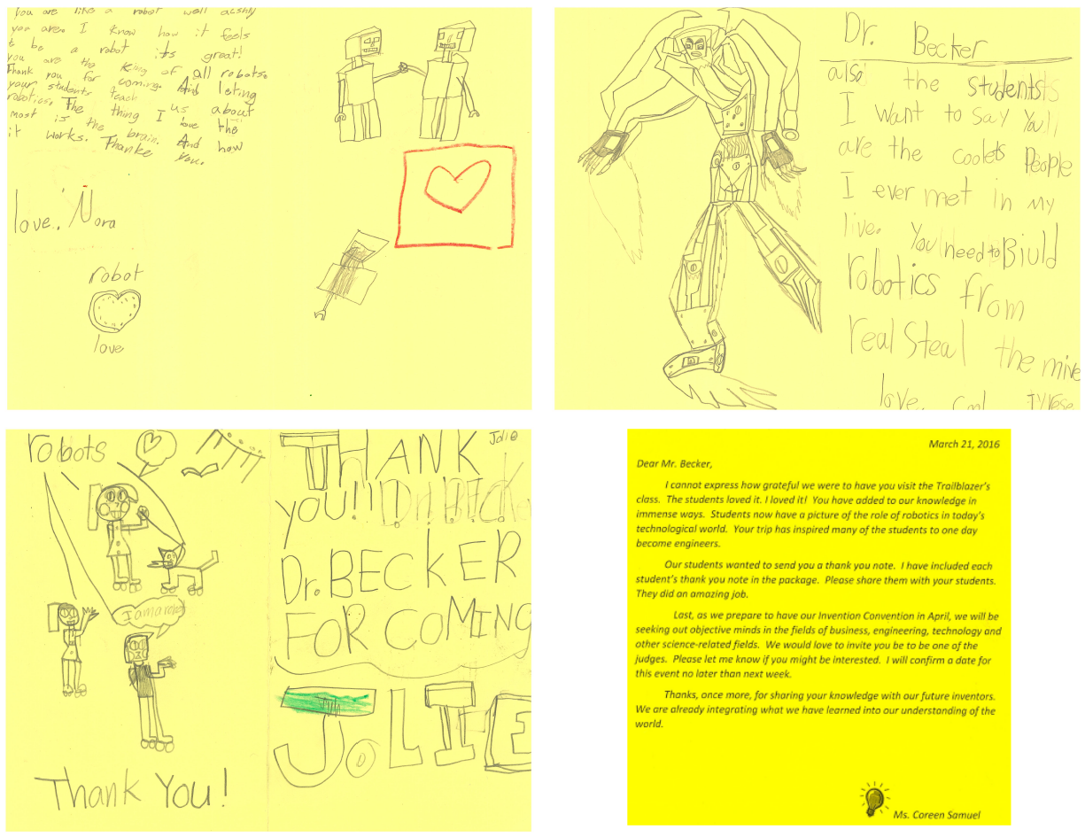

**Figure 3 – Some of our favorite thank you notes from University of Houston Charter School. Bottom right is a note from their teacher welcoming the University Team back to their class!**

On April 2nd 2016, the University of Houston hosted 150 elementary and middle school girls during *Chevron’s Girls Engineering the Future*. This afternoon event of hands-on activities was designed to encourage females to join the STEM field. Engineering is a male-dominated field and can be intimidating to some girls who are considering entering this field. To spark an interest in engineering and make the field seem more accessible, the University of Houston swarmathon team led “*Making Jewelry with Robots”,* an interactive demonstration of rapid prototyping machines led by female members of the team. During this demonstration, the team used the laser cutter to create a Texas shaped logo with UH engraved into it. The girls were then supervised to used a CNC mill, drill-press, and hand tools to create holes and construct souvenir earrings. Our github provides template and instructions for the outreach activity[9].

When the girls weren’t engaged with the hands on activities, lab members led discussions using the Swarmies, quadcopters, and other lab robots, as well as lessons on lab safety. Even when we blew a circuit breaker and had to temporarily halt earring production, the girls where excited to learn about lab projects from lab members. There was positive feedback not only from the girls but also from their chaperones. One chaperones was so impressed she claimed that if she had visited us before she had gone to college, even she would have ended up being an engineer!

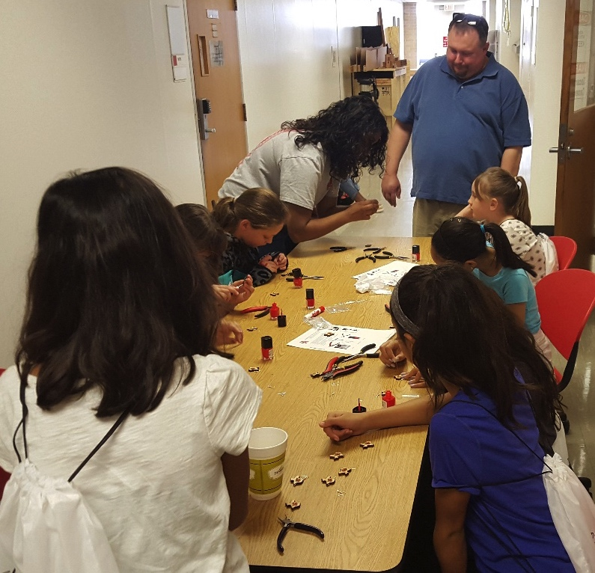

**Figure 4 – Girls from the “Chevron Girls Engineering the Future” event painting the laser–cut, CNC-milled souvenir earrings they made**

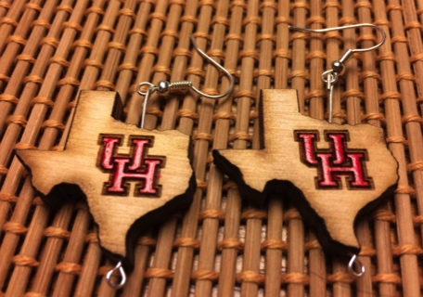Surveys on the girls in engineering outreach event have been sent out, but the results have not been released – but a wealth of anecdotal evidence and quotes assure us the event was a success. Due to event format we were unable to give a posttest, so no direct comparison between the events is possible.

Figure two lovingly-painted (with fingernail polish) earrings made by robots + female future engineers!

The University of Houston team has been enthusiastically asked by the teachers and engineering administration (and a handwritten appeal from twenty-three 2nd graders) to make both outreaches a yearly event. Dr. Becker’s policy that outreach is an integral part his lab’s training requires lab members to devote 10% of their time for outreach events. Several Swarmathon members were hired as undergraduate researchers, and will repeat *Making Jewelry with Robots* with the established Girls Reaching and Demonstrating Excellence summer camp. This will allow us to further assess and refine the activity.

APPENDIX I: UH-Main Team M­­­embers

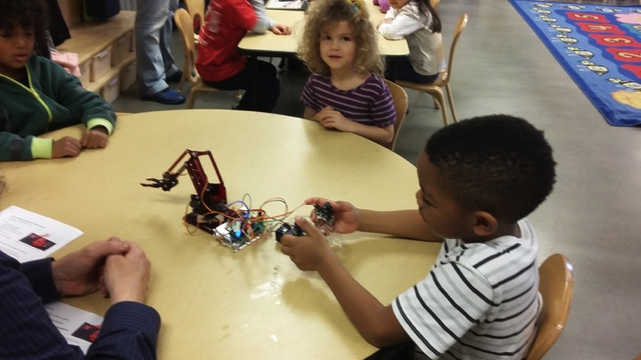Alyssa Peloso

An Nguyen

Arun Mahadev

Michael Brewer

Chandika Silva

Priya Dixit

Gary O'Day

Kaisong Fan

Haoran Zhao

Javier Garcia Gonzalez

Jasmine Hemdani

Jarrett Lonsford

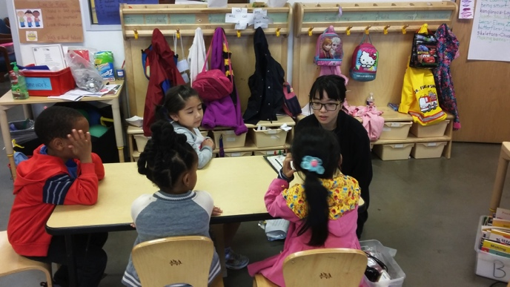Jordan Bowman

Keon McEwen

Li Huang

Mable Wan

Mark Alvarado

Mary Burbage

Mehmet Akdogan

Marvine Penson

Nathan Prows

Phat Nguyen

Lillian Lin

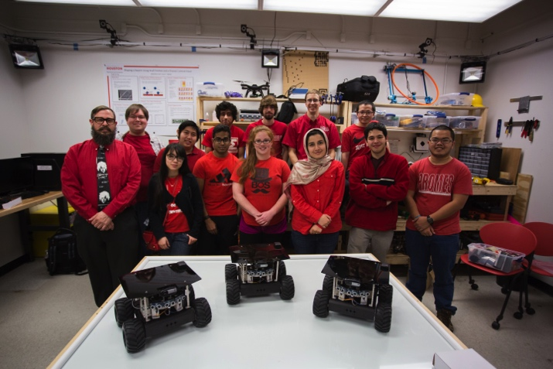Shiva Shahrokhi

Srikanth Kandanuru Venkata Sudarshan

Victor Montano

Joshua Zavala

1. For a full member list see­­­­ Appendix I
2. “We’ve made incredible progress on education, helping students to finance their college educations, but we still don’t have enough engineers” President Barack Obama, https://www.whitehouse.gov/the-press-office/2011/06/13/remarks-president-dnc-event-1
3. http://www.usnews.com/news/stem-solutions/articles/2015/02/24/stem-workforce-no-more-diverse-than-14-years-ago
4. https://www.egr.uh.edu/news/201603/students-steer-robotic-swarms-nasa-competition
5. https://twitter.com/controlswarm
6. http://www.uh.edu/charter-school/reports/federal-report-card-14.pdf
7. https://github.com /aabecker/RoboticSwarmControl Lab/tree/master/Outreach/Robot ArmOutreach%20K%20to%203rd %20grade
8. <https://github.com/aabecker/RoboticSwarmControlLab/blob/master/Outreach/RobotArmOutreach%20K%20to%203rd%20grade/Outreach_Surveys_University%20of%20Houston_2016.xlsx>
9. https://github.com/aabecker/RoboticSwarmControlLab/tree/master/Outreach/Robots%20to%20make%20Jewelry